|  |
| --- |
| **Calibration App** |
| **Version History**   |  |  |  |  | | --- | --- | --- | --- | | Date | Version | Author | Changes | | 27/07/2020 | 1 | L Boonekamp | Initial | |  |  |  |  | |

Contents

How to access the Calibration App 3

How to Update a Job 4

How to Delete a Job 5

How to add a new piece of Equipment 6

Views 7

Issues/Requests 7

# How to access the Calibration App

The Calibration app tracks and automatically creates new Calibration jobs for factory equipment.

Open <https://apps.powerapps.com/play/bc84cb5e-6f4f-411c-b703-abc6e160f587?tenantId=c3d4e9f2-27ad-4c0a-8519-de6ff3626339> in any web browser.

NOTE: To edit items, you need to be part of the Calibration access group. If you are not a member, you will see a message on the screen and the edit controls will be hidden.

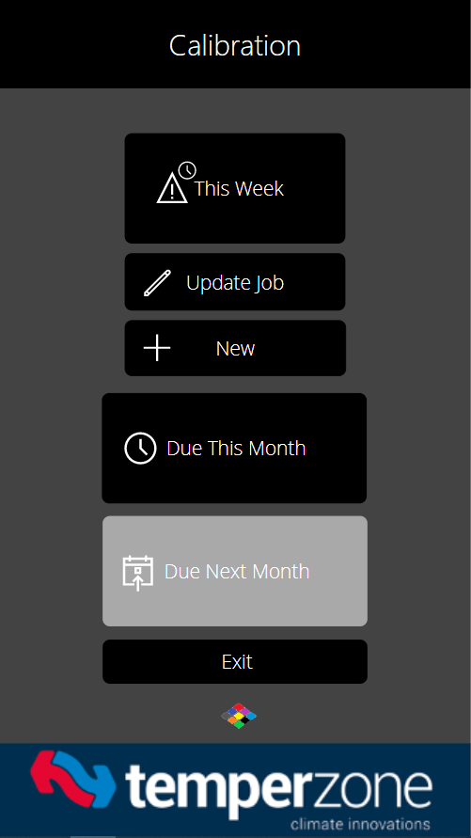

# How to Update a Job

Once you see the screen above, click on ‘This Week’. All of the Calibration jobs due this week are returned. Click the arrow on the item to go to the job.

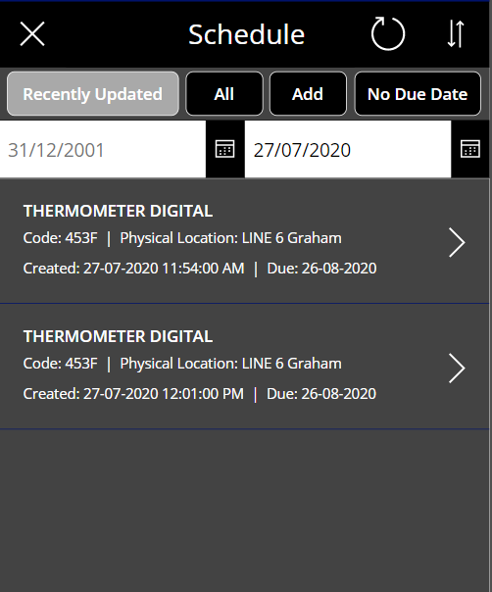

The Calibration Detail screen is displayed. Note: The job has a Status of ‘Scheduled’ meaning it’s awaiting completion. Click the pencil icon in the upper right-hand corner. The Update screen is displayed.

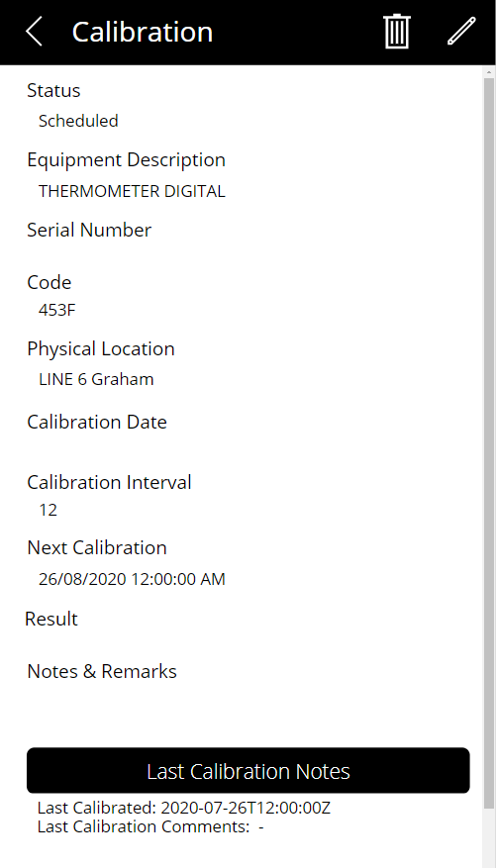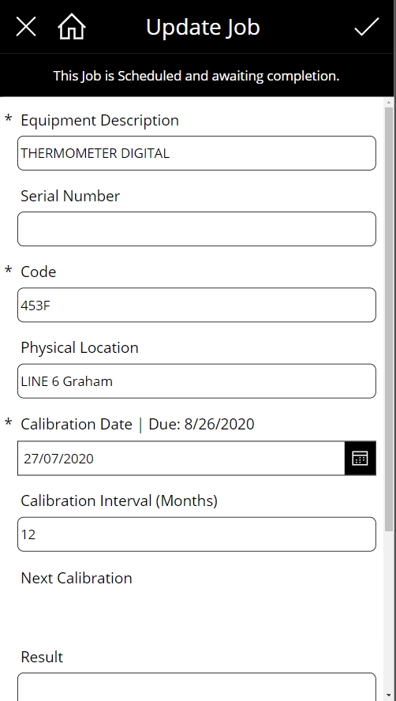

The Calibration Date automatically defaults to today’s date. The Calibration Interval value determines what the future Calibration Date will be and is a calculation of the Calibration Date + Calibration Interval. This value is then used when the job is completed and the system creates a new job.

Note that you must select the date using the Calendar button on any Date control.

To finish updating the item, click the tick icon in the upper right-hand corner. The following message is displayed.

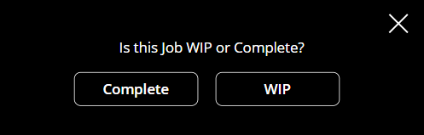

**WIP** – Marks this job as WIP and prevents the system from automatically creating a new Job in a Scheduled Status. Use this Status if the job is incomplete but being worked on.

**Complete** – Marks this job Completed and then creates a subsequent job with the Calibration Date + Calibration Interval as the Next Calibration Date.

# How to Delete a Job

Deleting a job is done from the Update screen and can only be done if you are a Calibration editor. i.e you are a member of the Calibration group.

To delete a job select the trash bin icon in the upper right-hand corner to the left of the pencil icon.

The following dialog is displayed.

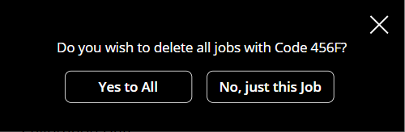

**Yes to All** – Deletes all calibration jobs with the code defined by the current item. I.e 456F.

**No, just this Job** – Performs a deletion of the current item only.

# 

# How to add a new piece of Equipment

From the Home screen, click the New button. The New Item screen is displayed.



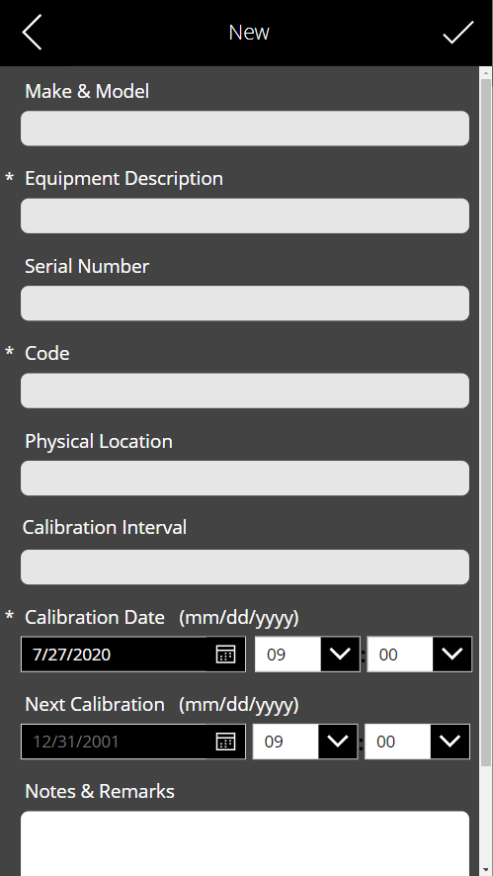

When you’ve finished entering the equipment details, click the tick icon in the upper right-hand corner. The following dialog is displayed.

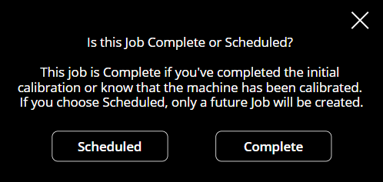

**Scheduled** – Marks this new entry as Scheduled (incomplete) which means it will need to be completed when the Next Calibration date is reached.

**Complete** – Marks this new entry as Completed, flagging the system to create a new entry for future calibration. Use this option if you’ve completed the intial calibration and are entering the item into the system for the first time.

# Views

From the Home screen, there are three quick view buttons as shown below. These filter the Calibration database as per the button text, i.e ‘This Week’ will show you jobs due this week.

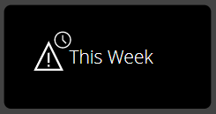 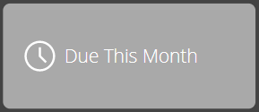 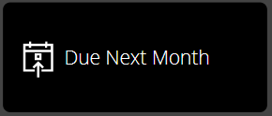

Performing a Date Range search

After clicking any of the above buttons, you can still perform a custom date range search.

The Date control on the left is the From date, the one on the right is the To date.

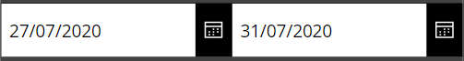

# Issues/Requests

If you have any issues, please remember to send them directly through to the Temperzone IT helpdesk

Email: [helpdesk@temperzone.com](mailto:helpdesk@temperzone.com?subject=RE:%20Notification) or Phone extension 888 in NZ or AU   
Or visit [helpdesk.temperzone.com](http://helpdesk.temperzone.com/)